# **Computer Hardware Identification**

**Date:**

**Group Name:**

**Group Members (2 Max):**

In this activity, in groups of 2, you will be taking a computer apart. Using a working computer and a phone, take pictures of the components and enter a description of the component and what it does. If the computer that is being dissected does not have the component, then getting an image from the internet is acceptable. Identify and describe the following computer components:

1. Case
   * Image:

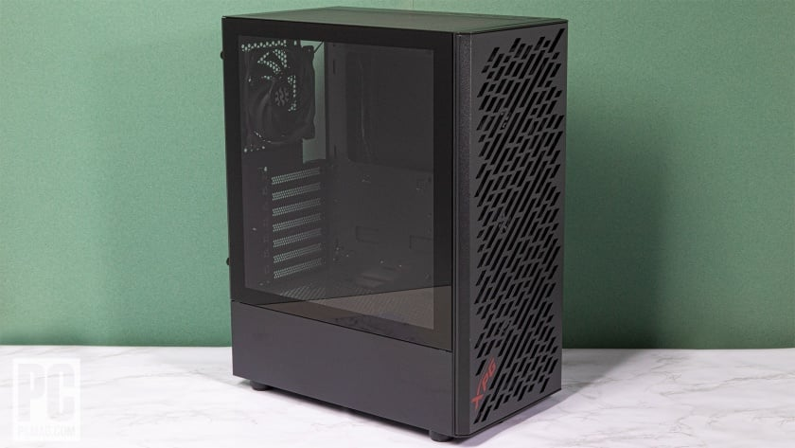

* + Description: A metal box surrounding the components
  + Function: protects the components of the pc

1. Motherboard
   * Image:

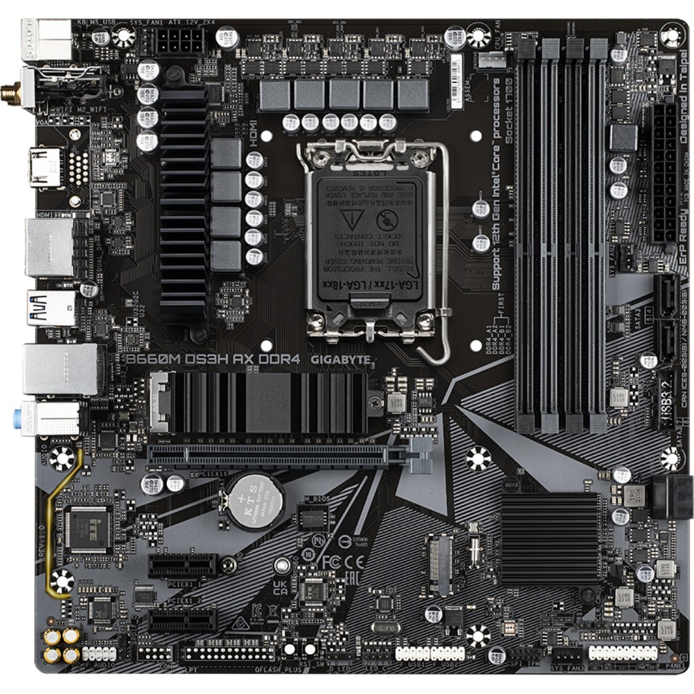

* + Description: a black board that houses components
  + Function: the vessel of most of the pc parts

1. CPU
   * Image:

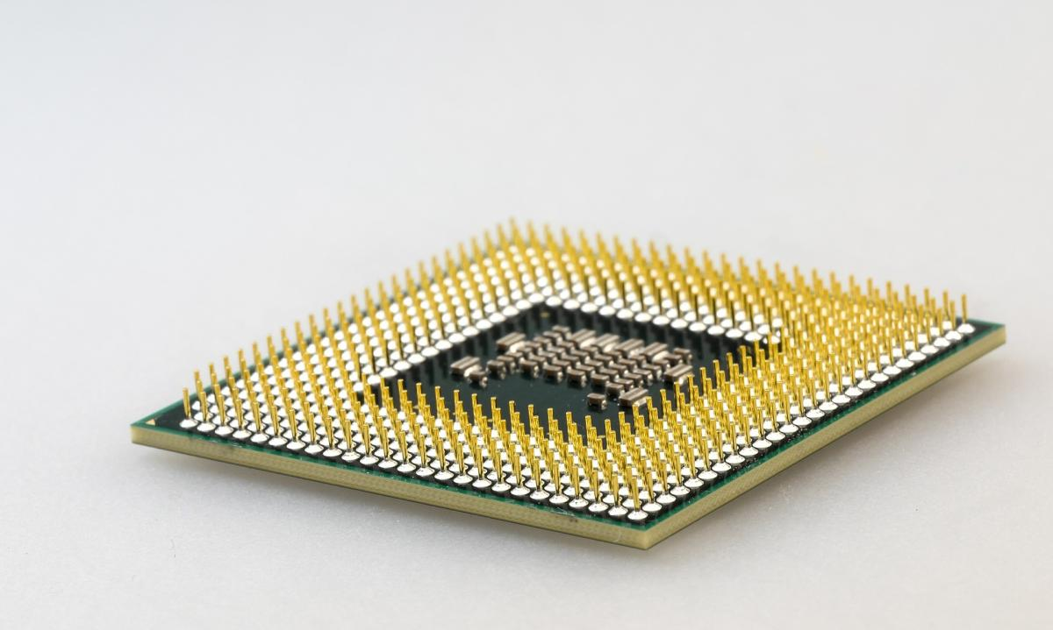

* + Description: a small chip that goes in the centre of the mother board
  + Function: it’s the brain of the pc

1. GPU
   * Image: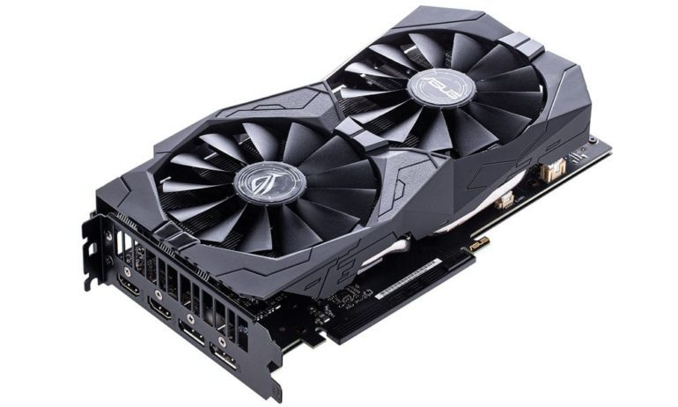
   * Description: disk that goes into the motherboard has fans to keep it cool
   * Function: gives the monitor a purpose by showing things on it
2. RAM
   * Image:

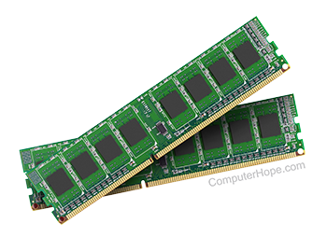

* + Description: a stick that gets slotted into the ram slots on the motherboard
  + Function: short term memory bank

1. Storage Device
   * SSD vs HDD
2. Cooling
   * CPU
     1. Image:

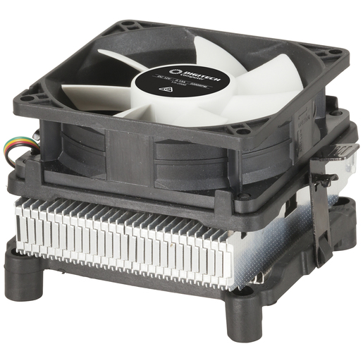

* + 1. Description: a fan that sits on top of the cpu.
    2. Function: makes sure the cpu doesn’t over heat by cooling it
  + Chassis
    1. Image: 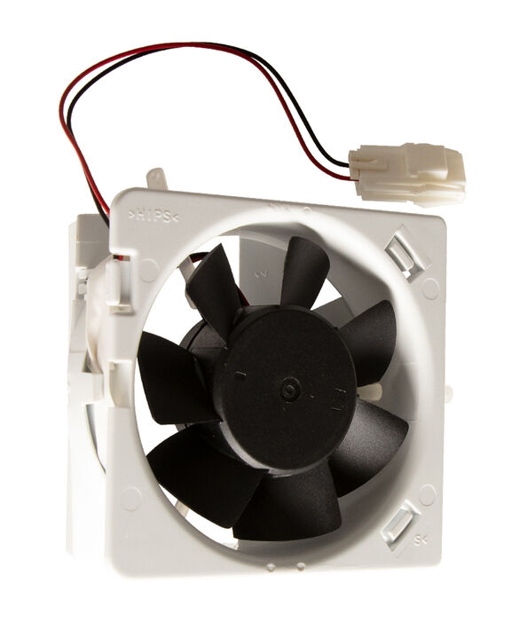
    2. Description: a fan that is usually stationed at the front and back of the case.
    3. Function: moves dust out of the pc as well as keeping a good airflow

1. PSU (Power Supply Unit)
   * Image: 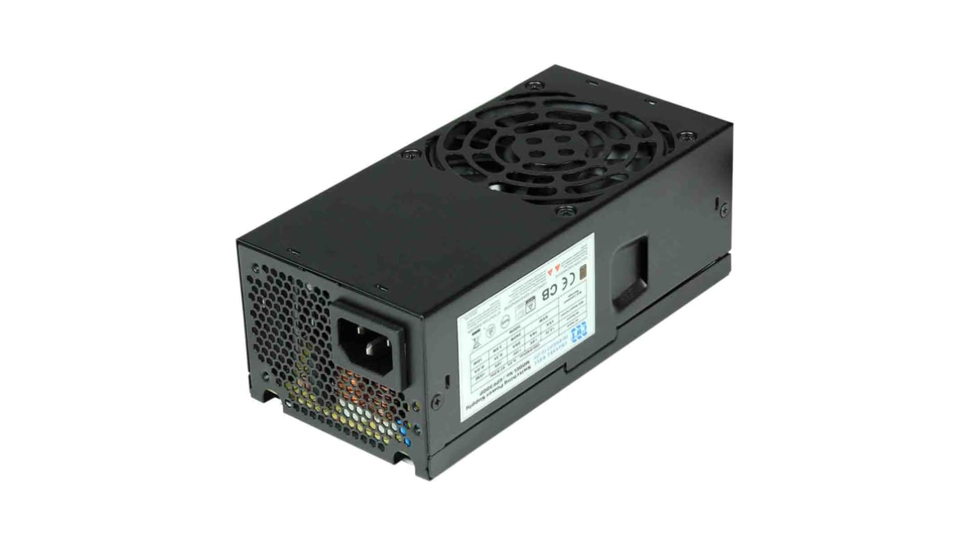
   * Description: a black box that is usually at the bottom corner of the case
   * Function: powers the pc
2. Monitor
   * Image: 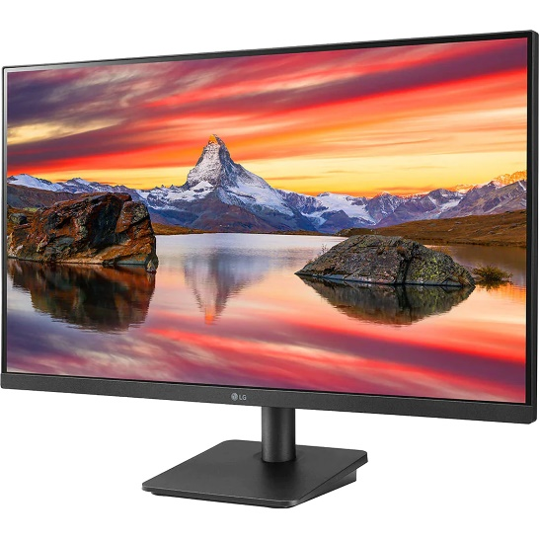
   * Description: a wide screen that you look at
   * Function: allows the gpu to have a purpose so that you can see
3. Mouse
   * Image: 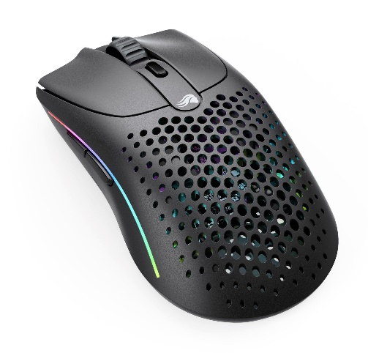
   * Description: a small thing that you move with your hand
   * Function: allows you to move your cursor
4. Keyboard
   * Image: 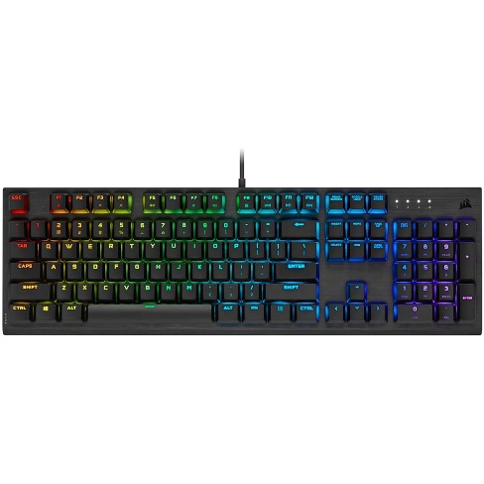
   * Description: a slate that has a lot of keys on it
   * Function: allows you to type